--UML diagram

UI Window:
MainWindow
-ui:Ui::MainWindow *;
-scene:QGraphicsScene * ;
+MainWindow()
-on_pushButton_1_clicked();
-on_pushButton_4_clicked();
-on_pushButton_2_clicked();
-delay( millisecondsToWait:Integer ):void;

About
-ui:Ui::About *
+About()

Score_window
-s:integer
-ui:Ui::Score_window *

+Score_window()
+getNUM(int)
+SHOW()
+~Score_window()

Objects:
AddDrum
-color:integer
-ss:Score
-player:QMediaPlayer *
+keyPressEvent(QKeyEvent *event)
+Dscorenumber():integer
+keyPressEvent(QKeyEvent *event)
slots:
+move()
+generate()

BigDrumBlue
+BigDrumBlue(QGraphicsItem * parent = 0)
slots:
+Hide()

BigDrumRed
+BigDrumRed(GraphicsIteem * parent = 0)
slots:
+Hide()

Circle
+Circle(QGraphicsItem * parenet = 0)

Game
-bigdrumred:BigDrumRed *
-bigdrumblue:BigDrumBlue *
-circle:Circle *
-t:TT *
-adddrum:AddDrum *
-scene:QGraphicsScene *
-Swindow:QgraphicsScene *
-view:QGraphicsView *
-Sview:QGraphicsView *
-num:integer
+Game()
+delay(integer)
+stop()
+Play()

Score
+Score(parent:QgraphicsItem*)
+plus(integer)
+delay(integer)

scoretext
+scoretext(parent: QGraphcisItem *)

TT
-time_left:integer
-score:integer
+TT(parent QGraphicsItem *)
+~TT()
+ctime()
+player:QMediaPalyer *

--ScreenShot

1. Start menu : include Start
Usage
About
Exit
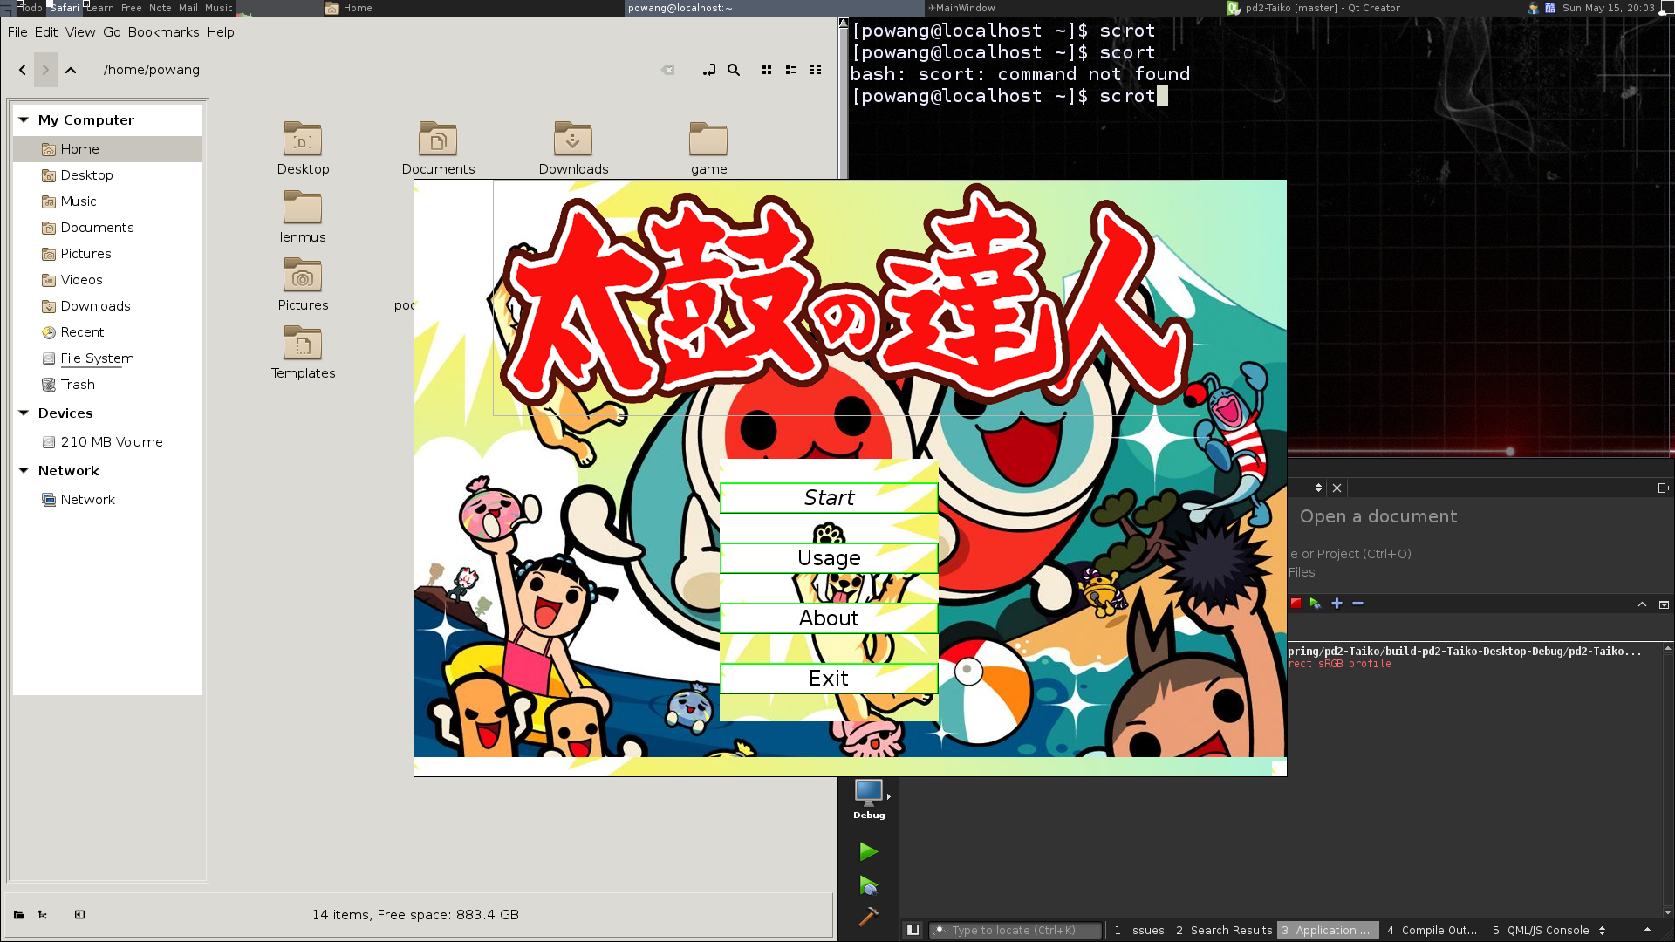
2. In Game: after pushing start button in start menu
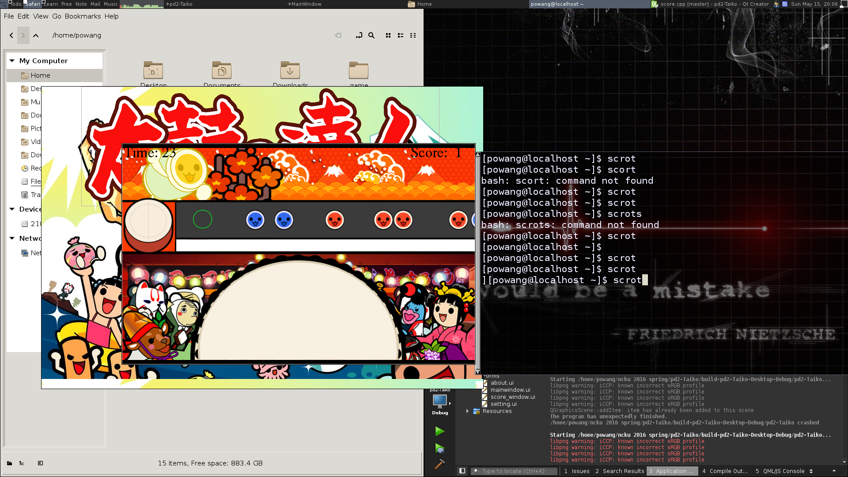
3. Score: When game finished, pop up score window
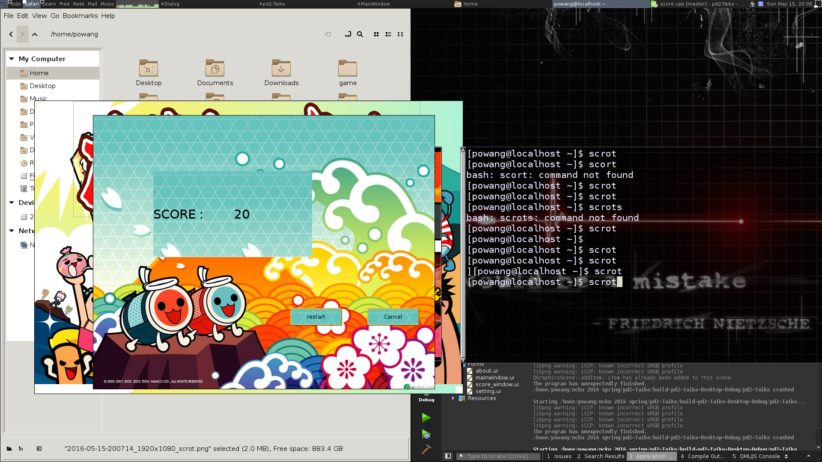
4.About
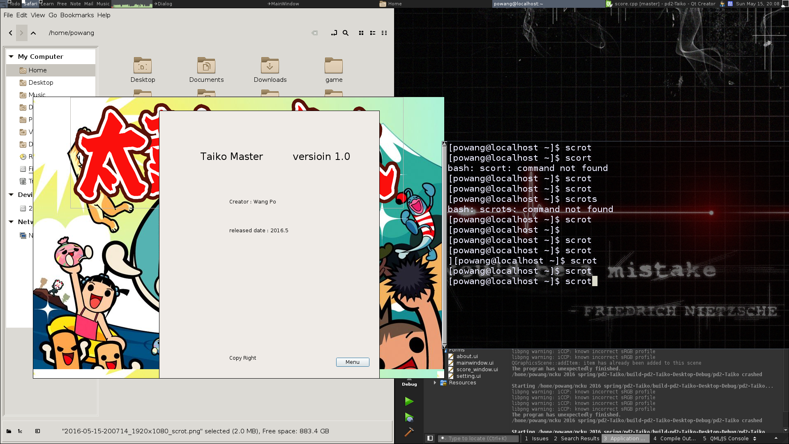

5.Usage: Tell you how to play game
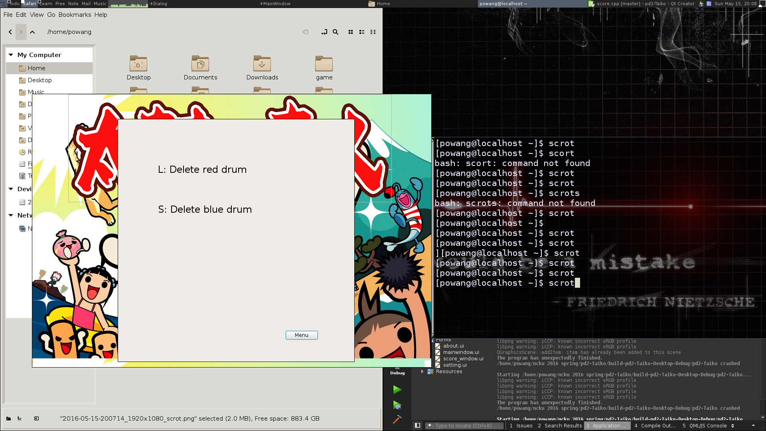
--How to Play

in start menu, push Start. The game will begin. If there comes red drum to the green circle , press Keyboard’s L to elimate it, otherwise , if there comes blue drum , press S to eliminate it. After 30 seconds , the game will stop. And then , score menu will appear. It shows how many scores did you gain in game. Press “ restart ” or “ cancel ” to restart game or exit game.

--Program Architecture

(Next page)

Start menu
exit game
About
Usage
start game
Game screen
Score
Time
drum
add drum
times up
30 seconds
restart
cancel
Score

